The **lux** (symbol: **lx**) is the **SI unit of illuminance**, which is a measure of the total **luminous flux** (light) incident on a surface per unit area. In simpler terms, lux quantifies how brightly a specific surface is illuminated, taking into account how much visible light is spread over that area.

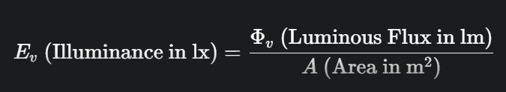

* **Lumen (lm)** The SI unit of **luminous flux**, which is the total amount of visible light emitted by a source.4 The lumen value tells you the light source's total output.5
* **Lux (lx)** The measure of how that light output is distributed over a surface